Derivatives — Core Pricing
Forwards, Futures, Option Payoffs, Put-Call Parity, Binomial Trees, Black-Scholes, Implied Volatility & the Greeks
Pricing Contracts Whose Value Derives From an Underlying Asset, and Measuring Their Sensitivities
A Level 2 module in the Quantitative Finance Curriculum — revisited at Level 5
Covers: Forwards/futures · option payoffs (calls/puts) · moneyness/intrinsic/time value · put-call parity · binomial trees · Black-Scholes · implied volatility · Greeks (delta/gamma/vega/theta/rho)

Table of Contents
How to Use This Guide
What You Need to Know Before Starting
Understand Before Proceeding
Why It Matters
How This Connects to the Rest of the Curriculum
Glossary of Recurring Terms
Part 1 — Forwards and Futures: The Simplest Derivatives
1.1 Forward Contracts and Linear Payoffs
1.2 Futures vs. Forwards: Marking to Market
1.3 Forward Pricing: Cost of Carry
Part 2 — Option Payoffs and Moneyness
2.1 Calls and Puts: Payoff at Expiration
2.2 Moneyness: ITM, ATM, OTM
2.3 Intrinsic Value and Time Value
Part 3 — Put-Call Parity
3.1 The Parity Relationship
3.2 Arbitrage and Synthetic Positions
Part 4 — Binomial Trees
4.1 The One-Step Binomial Model
4.2 Multi-Step Trees and Risk-Neutral Pricing
Part 5 — The Black-Scholes Model
5.1 Assumptions and the Formula
5.2 Reading the Formula: d₁, d₂, and N(·)
Part 6 — Implied Volatility
6.1 Inverting Black-Scholes for Volatility
6.2 The Volatility Smile and Skew
Part 7 — The Greeks: Risk Sensitivities
7.1 Delta and Gamma
7.2 Vega, Theta, and Rho
7.3 Reading the Greeks Together as a Risk Dashboard
Practical Exercise
Common Beginner Mistakes
Advanced Extensions
Professional Applications
Where to Go Next

How to Use This Guide
This document is a companion to Derivatives — Core Pricing, the second-level module in the quantitative finance curriculum that is revisited in more depth at Level 5. It covers the mathematics of pricing contracts whose value derives from an underlying asset — forwards, futures, and options — and the standard vocabulary (the Greeks) used to measure how that value responds to changes in the market.
The module is self-contained: every concept is introduced from first principles, paired with a worked numerical example and a short runnable Python sketch, and illustrated with a chart or diagram wherever a picture makes the idea land faster than a formula. Read it start to finish if derivatives pricing is new to you, or jump straight to the section you need.

What You Need to Know Before Starting
- Calculus — derivatives and partial derivatives, since the Greeks (Part 7) are, literally, partial derivatives of an option's price with respect to each input.
- Probability — the normal distribution, its cumulative distribution function N(·), and expectation, all used directly in the Black-Scholes formula (Part 5).
- Basic Stochastic Mathematics awareness — an intuitive sense that asset prices are modelled as evolving randomly through time (e.g., geometric Brownian motion); a full treatment is not required at this level, only the awareness that this is the modelling assumption underneath Black-Scholes.

Understand Before Proceeding
Prerequisite gate — Do not treat Black-Scholes as a black box that outputs 'the' correct option price. Every price it produces is conditional on its assumptions (constant volatility, continuous trading, no jumps, log-normal returns) holding well enough to be useful — understanding what those assumptions are, and where they break, matters as much as being able to compute d₁ and d₂.

Why It Matters
Derivatives are used for hedging, leverage, and volatility trading across every asset class — equities, rates, credit, commodities, and FX. A pension fund hedging equity exposure, a corporation locking in a future exchange rate, and a volatility desk expressing a view on future turbulence are all, underneath, using the same core pricing machinery covered in this module. The Greeks are the standard risk vocabulary for any options position: they are not an academic add-on to the pricing formulas, they are literally how an options book is monitored and hedged in real time, every trading day.

How This Connects to the Rest of the Curriculum
- Research — Implied-volatility-based signals and volatility risk-premium research require this foundation — you cannot reason about whether implied volatility is rich or cheap relative to realised volatility without first understanding what implied volatility actually is (Part 6).
- Development — Pricing libraries — binomial trees, Black-Scholes closed-form, and their Greeks — are common reusable research infrastructure; getting the reference implementation right once, and testing it thoroughly, avoids every downstream researcher re-deriving (and potentially mis-deriving) the same formulas.
- Trading — The Greeks are literally the desk's real-time risk dashboard for an options book — position limits, hedging decisions, and P&L attribution are all expressed directly in terms of delta, gamma, vega, theta, and rho.

Glossary of Recurring Terms
Forward contract — A private agreement to buy or sell an asset at a fixed price (the forward price) on a fixed future date, with no cash changing hands until settlement.
Futures contract — An exchange-traded, standardized forward contract that is marked to market daily, so gains and losses are settled in cash each day rather than accumulated until expiry.
Call option — A contract giving its holder the right, but not the obligation, to buy the underlying asset at a fixed strike price on or before expiration.
Put option — A contract giving its holder the right, but not the obligation, to sell the underlying asset at a fixed strike price on or before expiration.
Moneyness — A description of an option's strike relative to the current underlying price — in the money (ITM), at the money (ATM), or out of the money (OTM).
Intrinsic value — The value an option would have if exercised immediately — max(S−K, 0) for a call, max(K−S, 0) for a put.
Time value — The portion of an option's price above its intrinsic value, reflecting the possibility that intrinsic value could increase before expiration; it decays to zero as expiration approaches.
Put-call parity — A no-arbitrage relationship linking the prices of a European call, a European put, the underlying, and a zero-coupon bond, all with the same strike and expiry.
Binomial tree — A discrete-time model in which the underlying price moves up or down by a fixed factor at each step, used to price options by working backward from expiry (backward induction).
Risk-neutral probability — The probability of an up-move used in binomial and Black-Scholes-style pricing, chosen specifically so that the underlying's expected return equals the risk-free rate — a pricing device, not a real-world forecast.
Black-Scholes model — A closed-form model for pricing European options under specific assumptions (constant volatility, continuous trading, log-normal returns, no dividends or jumps).
Implied volatility (IV) — The volatility input that, when fed into Black-Scholes, reproduces an option's observed market price — a market-implied price input, not a forecast of future realised volatility.
Volatility smile / skew — The empirical pattern in which implied volatility varies systematically by strike (and by expiry) rather than remaining flat as the constant-volatility Black-Scholes assumption would imply.
Delta (Δ) — The sensitivity of an option's price to a small change in the underlying price — the first Greek, and the basis of delta hedging.
Gamma (Γ) — The sensitivity of delta itself to a small change in the underlying price — the rate of change of the rate of change.
Vega (ν) — The sensitivity of an option's price to a small change in implied volatility.
Theta (Θ) — The sensitivity of an option's price to the passage of time, holding everything else fixed — the rate of time decay.
Rho (ρ) — The sensitivity of an option's price to a small change in the risk-free interest rate.

Part 1 — Forwards and Futures: The Simplest Derivatives
Forwards and futures are the simplest derivatives: an agreement today to transact at a fixed price on a fixed future date, with a payoff that is a straight line in the underlying price at expiry — no optionality, no kink, and (at initiation) no premium changing hands. This part covers their payoff structure, the mechanical difference between forwards and futures, and how a fair forward price is determined.

1.1 Forward Contracts and Linear Payoffs
A long forward position obligates its holder to buy the underlying at the agreed forward price F on the delivery date, regardless of where the market price Sᵀ has moved to by then. Its payoff at expiry is simply:
Long forward payoff = Sᵀ − F Short forward payoff = F − Sᵀ
Because there is no right to walk away — a forward is an obligation, not an option — the payoff can be negative without limit (for the long side, if Sᵀ falls far below F) as easily as positive. This linearity, and the corresponding symmetry between the two sides of the contract, is what most sharply distinguishes forwards and futures from the options covered in Part 2.
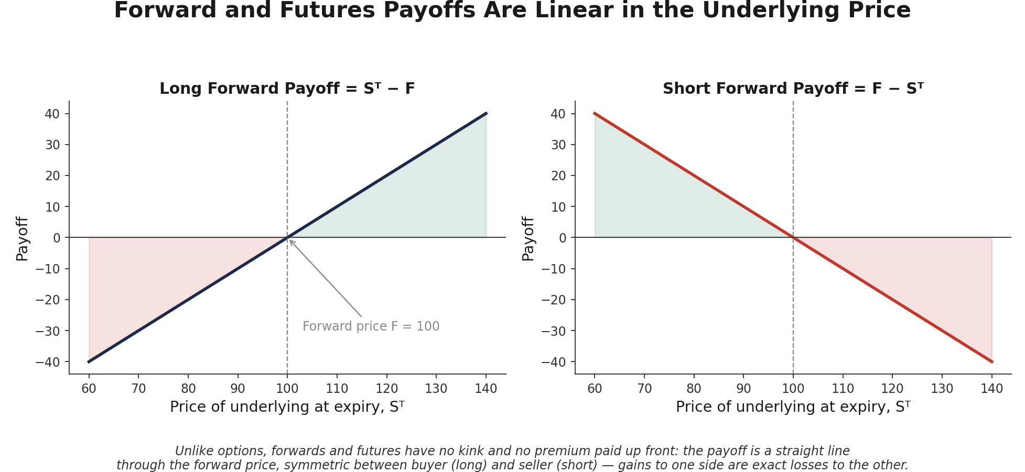
Figure 1.1 — Long and short forward payoffs are mirror-image straight lines through the forward price F. Every dollar gained by one side of the contract is a dollar lost by the other — a zero-sum, symmetric exposure with no premium paid up front.

1.2 Futures vs. Forwards: Marking to Market
A futures contract is economically similar to a forward — same linear payoff, same obligation to transact — but is exchange-traded, standardized, and marked to market daily: gains and losses are settled in cash at the end of each trading day, rather than accumulating silently until the final delivery date. This daily settlement is what allows an exchange to guarantee both sides of the contract through a central clearinghouse, largely eliminating the counterparty risk (Risk Metrics module, Section 5.2) that a bilateral, uncleared forward carries.
Tip — For most pricing purposes at this level, forwards and futures can be treated as economically equivalent — their prices coincide exactly when interest rates are deterministic (non-random). A materially different futures price for the same maturity and underlying should prompt a check of the interest-rate assumption, not an assumption that the two products are simply unrelated.

1.3 Forward Pricing: Cost of Carry
The fair forward price is set by a no-arbitrage argument: buying the asset today and holding it to the delivery date must cost the same, in present-value terms, as agreeing today to buy it forward. For a non-dividend-paying asset:
F = S₀ × e^(rT) (cost-of-carry formula, continuous compounding)
For an asset paying a continuous dividend yield q (or, equivalently, for an FX forward where q is the foreign risk-free rate), the formula adjusts to F = S₀ × e^((r−q)T) — the dividend (or foreign interest) received while holding the physical asset offsets part of the financing cost of carrying it forward. If the quoted forward price in the market differs from this fair value, a cash-and-carry arbitrage (buy the underlying, short the forward, or the reverse) is available in principle, which is exactly the force that keeps quoted forward prices close to this formula in liquid markets.
import numpy as np

S0, r, q, T = 100, 0.03, 0.00, 0.5 # spot, risk-free rate, dividend yield, years
forward_price = S0 * np.exp((r - q) * T)
# forward_price = 101.51 for these inputs

Part 2 — Option Payoffs and Moneyness
Unlike a forward, an option gives its holder a right without an obligation — and that asymmetry is exactly what a premium is paid for. This part covers the payoff structure of calls and puts, the vocabulary used to describe an option's strike relative to the current price (moneyness), and the decomposition of an option's value into intrinsic value and time value.

2.1 Calls and Puts: Payoff at Expiration
A call option's payoff at expiry is the amount by which the underlying finished above the strike, or zero if it did not; a put option's payoff is the mirror image:
Call payoff = max(Sᵀ − K, 0) Put payoff = max(K − Sᵀ, 0)
Because the holder of a long option can simply let it expire worthless if it is unfavourable, the payoff can never be negative — the most a buyer can lose, in total, is the premium paid up front. The seller (writer) of the option takes the opposite side of exactly that asymmetry: capped income (the premium received), against a loss that is large (short call) or bounded but potentially severe (short put, bounded by the underlying falling to zero).
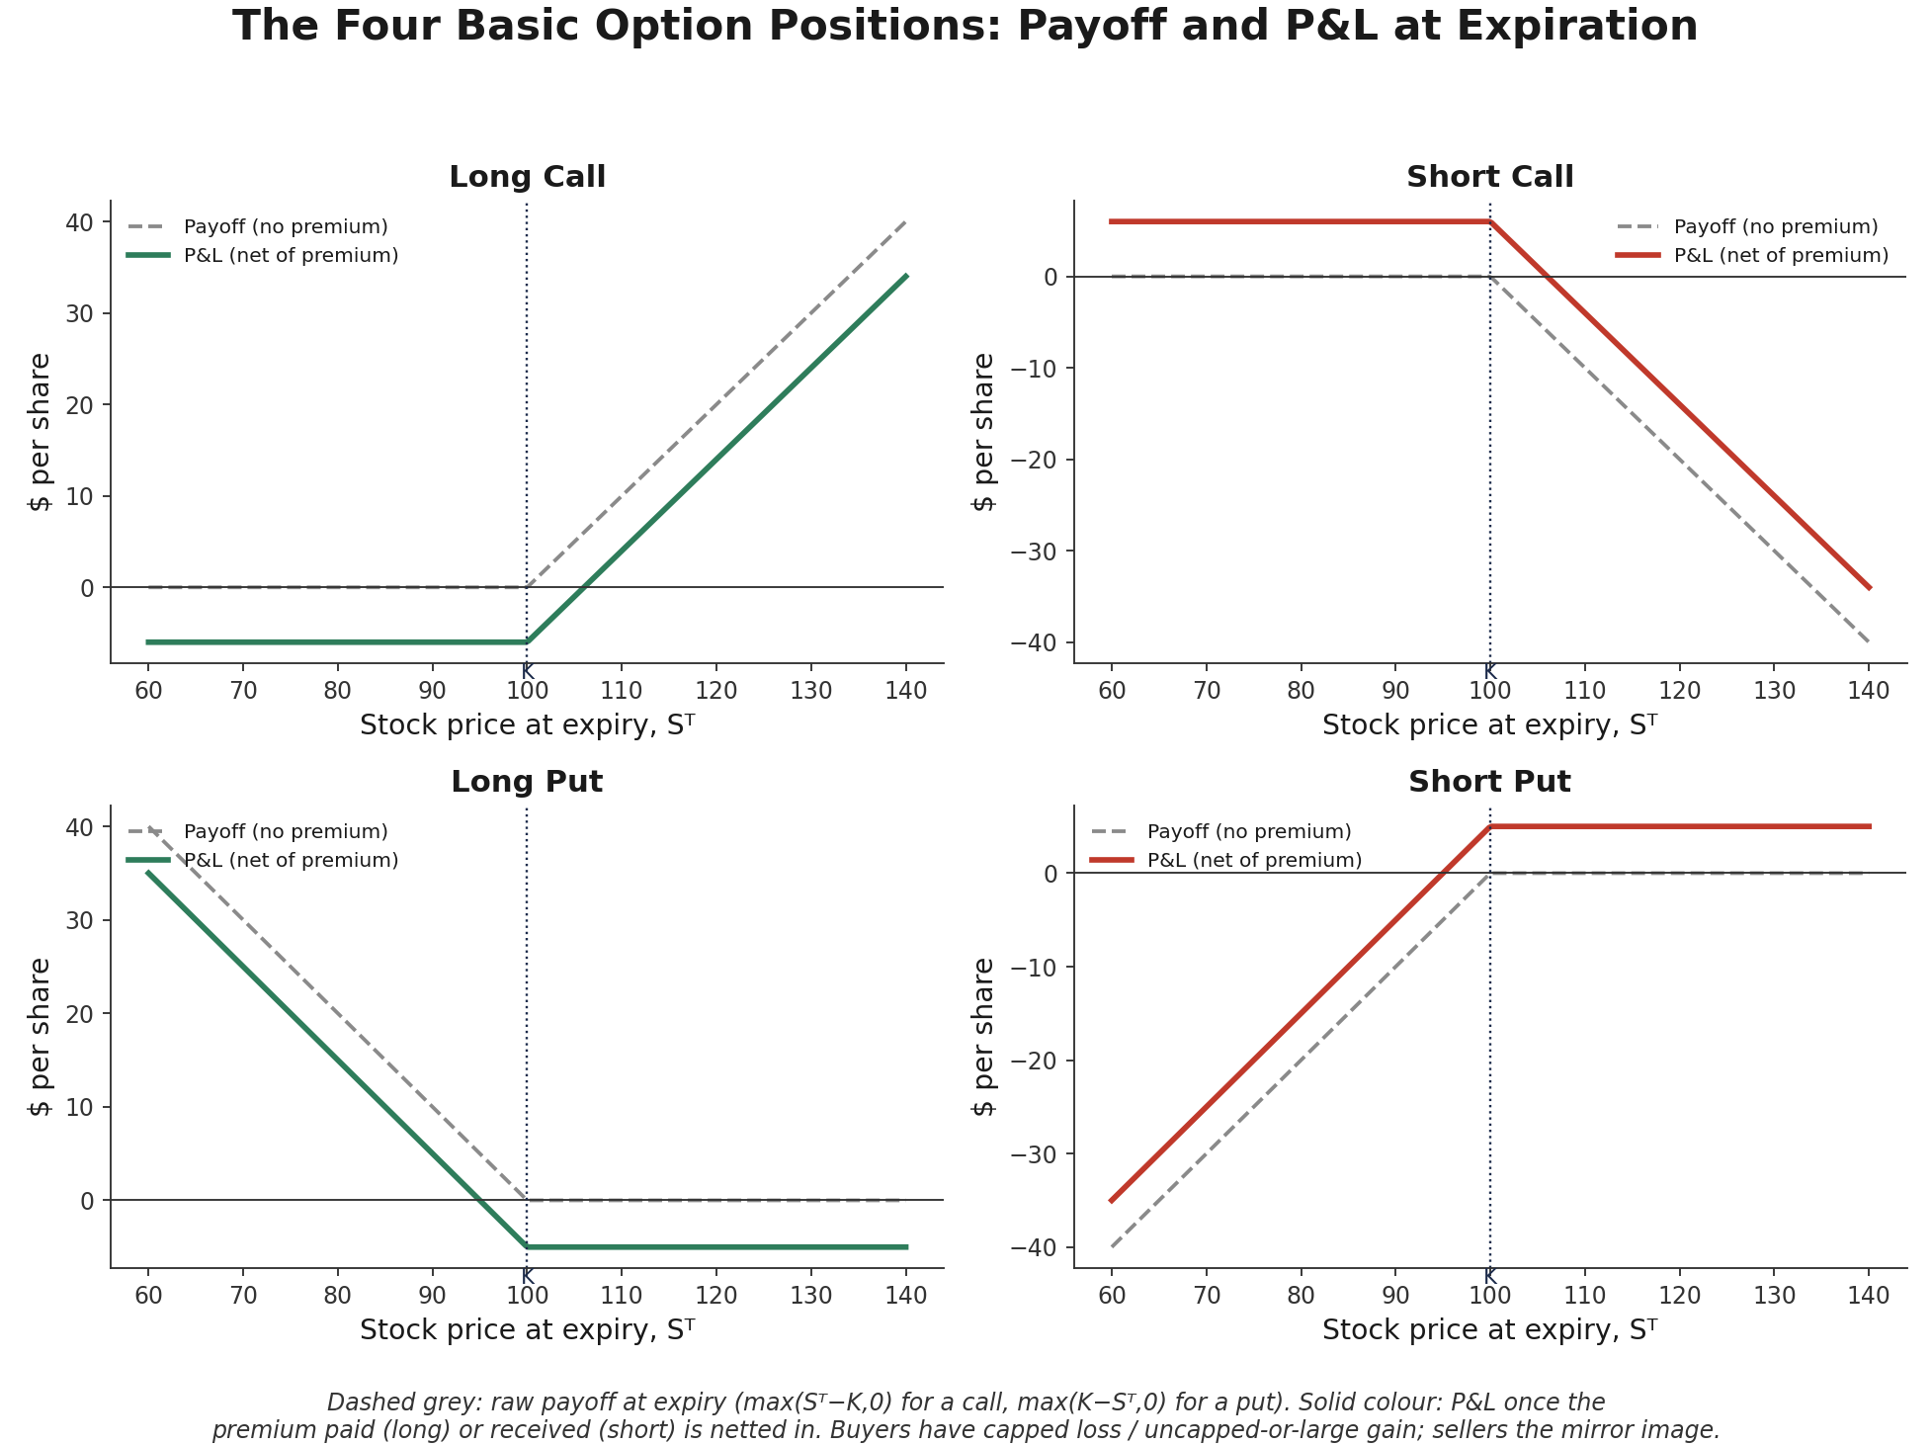
Figure 2.1 — The four basic option positions. Long positions (top-left, bottom-left) have a payoff floor of zero and pay a premium for that protection; short positions (top-right, bottom-right) collect the premium up front against an uncapped-or-large potential loss. Note the strict symmetry between each long/short pair.

2.2 Moneyness: ITM, ATM, OTM
Moneyness describes an option's strike relative to the current underlying price, independent of how much time value it carries:
- In the money (ITM) — a call with S > K, or a put with S < K: the option has positive intrinsic value if exercised right now.
- At the money (ATM) — S ≈ K: the option has (approximately) zero intrinsic value; in practice, the strike closest to the current forward price is usually called the ATM strike.
- Out of the money (OTM) — a call with S < K, or a put with S > K: the option has zero intrinsic value, and its entire premium is time value.

2.3 Intrinsic Value and Time Value
Every option's price decomposes cleanly into two pieces:
Option price = Intrinsic value + Time value
Intrinsic value is what the option would be worth if exercised this instant (Section 2.1's payoff formula, evaluated at today's spot rather than at expiry). Time value is everything else — compensation for the possibility that a currently OTM option could move into the money, or that an ITM option could move further into the money, before expiration. Time value is always non-negative for a standard option, is largest for at-the-money options with the most time remaining, and decays toward zero as expiration approaches — a decay path governed by theta (Section 7.2).
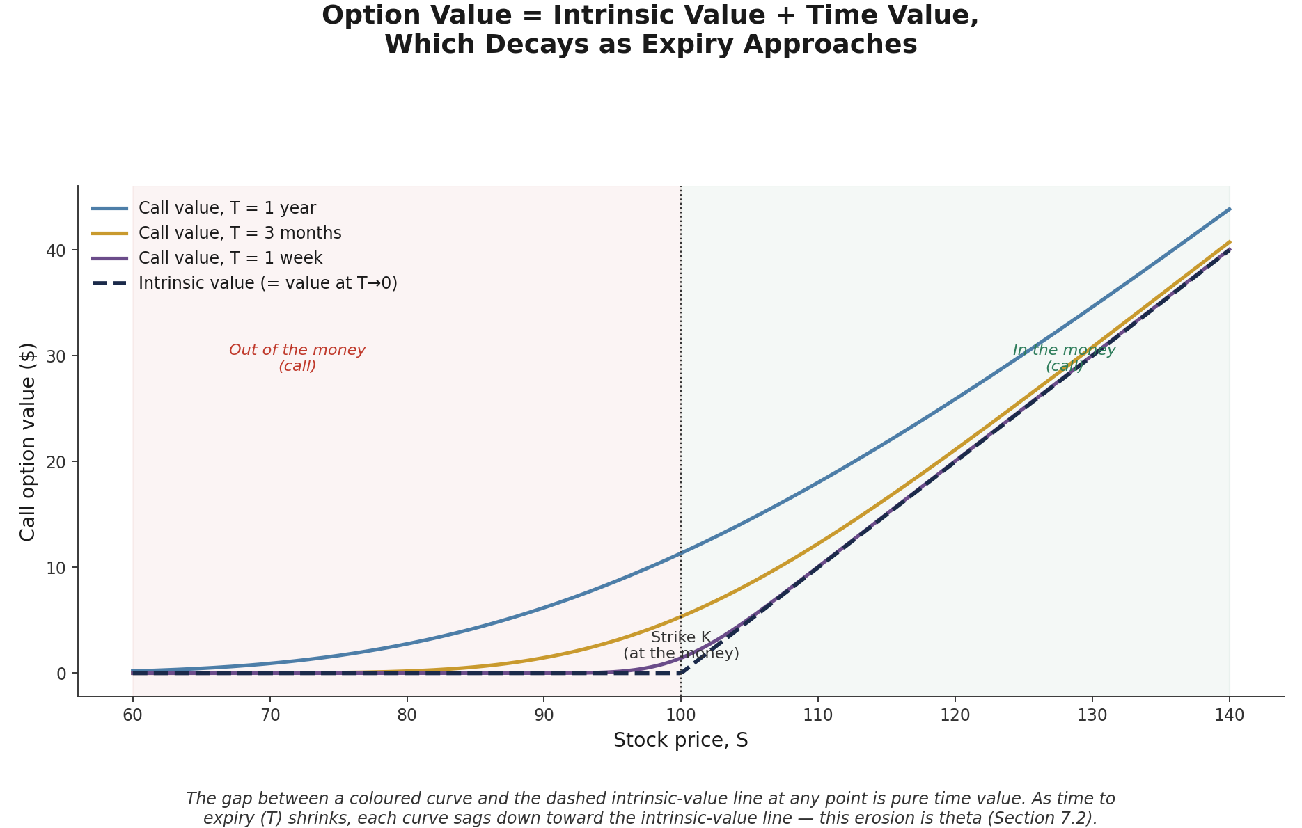
Figure 2.2 — A call option's value (coloured curves) sits above its intrinsic value (dashed line) by exactly the amount of time value remaining. As time to expiry shrinks from one year to one week, the curve sags down toward the intrinsic-value line — most visibly for out-of-the-money and at-the-money strikes, which have no intrinsic value to fall back on.
intrinsic_call = max(S - K, 0)
time_value = option_price - intrinsic_call # always >= 0 for a standard option

Part 3 — Put-Call Parity
Put-call parity is the single most important no-arbitrage relationship in options pricing: it links the price of a call, a put, the underlying, and a bond of the same strike and maturity, purely through a replication argument — no model of the underlying's dynamics, and no assumption about volatility, is required to derive it.

3.1 The Parity Relationship
For European options on a non-dividend-paying asset, with the same strike K and expiry T:
C₀ + K·e^(−rT) = P₀ + S₀
The left-hand side (a fiduciary call: a long call plus enough cash, invested at the risk-free rate, to equal K at expiry) and the right-hand side (a protective put: the underlying plus a long put) produce exactly the same payoff at every possible expiry price Sᵀ — both are worth max(Sᵀ, K).
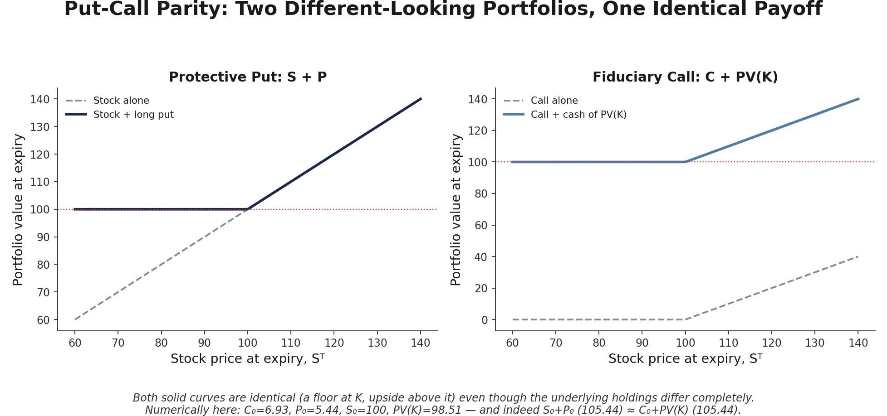
Figure 3.1 — A protective put (own the stock, buy a put as insurance) and a fiduciary call (own a call, hold cash equal to the discounted strike) produce an identical payoff diagram at expiry — a floor at K with unlimited upside above it. Since two portfolios with identical payoffs in every state of the world must have identical prices today, their initial costs must be equal, which is exactly put-call parity.
Because the relationship must hold by replication alone, any violation is a genuine, model-free arbitrage: if C₀ + Ke^(−rT) > P₀ + S₀, selling the (overpriced) fiduciary call and buying the (underpriced) protective put locks in a riskless profit today, with the two payoffs cancelling exactly at expiry regardless of where the underlying ends up.

3.2 Arbitrage and Synthetic Positions
Rearranging the parity formula produces a family of synthetic positions — replicating one instrument out of the other three:
Synthetic long call: C = P + S − K·e^(−rT) Synthetic long put: P = C − S + K·e^(−rT)
Synthetic long stock: S = C − P + K·e^(−rT) Synthetic bond: K·e^(−rT) = C − P + S ... rearranged as needed
Trading desks use these relationships routinely — for example, to construct a synthetic long stock position out of options when the stock itself is hard to borrow or expensive to short, or to check that a quoted option price is internally consistent with the corresponding put, call, and forward prices before trading on it.
Common mistake — Applying put-call parity to American options without adjustment. The clean equality above holds for European options (exercisable only at expiry); American options (exercisable any time) can command an early-exercise premium — most relevantly for puts on non-dividend-paying stocks, and for calls on dividend-paying stocks just before a dividend — so the equality becomes an inequality rather than an exact identity.

# Numerical check of put-call parity
lhs = C0 + K * np.exp(-r * T) # fiduciary call
rhs = P0 + S0 # protective put
assert abs(lhs - rhs) < 1e-6, 'Parity violated — check inputs or look for arbitrage'

Part 4 — Binomial Trees
The binomial model prices an option by assuming the underlying can only move to one of two prices over each small time step, then working backward from known payoffs at expiry to a fair value today. It is less elegant than Black-Scholes but far more flexible — American exercise, dividends, and other complications are easy to bolt on — and it makes the risk-neutral pricing logic underneath every derivative pricing model in this module concrete and auditable step by step.

4.1 The One-Step Binomial Model
Suppose a stock at price S can move up to Su or down to Sd over one period, and a call struck at K is worth Cᵤ or C_d at the corresponding nodes. The key insight is that a portfolio of Δ shares of stock plus a bond can be constructed to replicate the option's payoff exactly in both the up and down state — and since that replicating portfolio's cost is observable today, so is the option's fair price, without needing to know the real-world probability of an up-move at all:
Δ = (Cᵤ − C_d) / (Su − Sd) C₀ = e^(−rΔt)[p·Cᵤ + (1−p)·C_d], where p = (e^(rΔt) − d) / (u − d)
The quantity p is the risk-neutral probability — not a forecast of the real-world likelihood of an up-move, but the specific probability that makes the underlying's expected return equal the risk-free rate under the pricing measure. This is the central conceptual leap of derivatives pricing: the option is priced as if investors were risk-neutral, precisely because the replicating-portfolio argument makes actual risk preferences irrelevant to the fair price.

4.2 Multi-Step Trees and Risk-Neutral Pricing
Extending to multiple steps simply repeats the one-step logic recursively: build the tree of underlying prices forward from today to expiry, compute the option's payoff at every terminal node, then work backward one step at a time, discounting the risk-neutral expected value at each node until the root (today) is reached — exactly the backward induction shown in Figure 4.1.
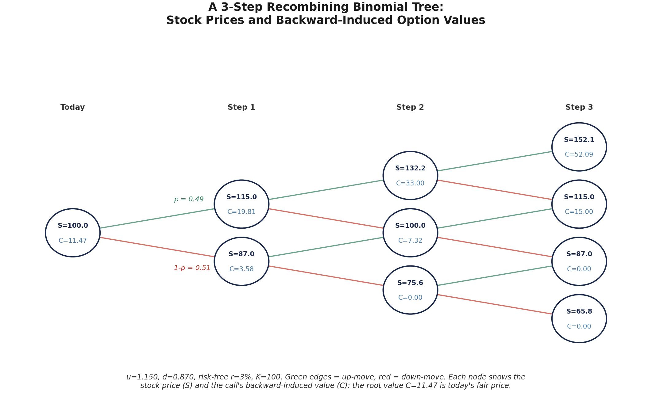
Figure 4.1 — A 3-step recombining binomial tree for a call struck at K=100. Forward pass (left to right): the stock price at each node is S₀uⁱdʲ. Backward pass (right to left, using the terminal payoffs and the formula above): each node's option value is the discounted, risk-neutral-weighted average of its two children. The root value is today's fair price for the option.
As the number of steps increases (with the time step correspondingly shrinking) and u, d are chosen appropriately, the binomial tree's price converges to the Black-Scholes price of Part 5 — the two models are not competitors so much as a discrete-time and continuous-time version of the same no-arbitrage, risk-neutral pricing logic.
def binomial_call(S0, K, T, r, u, d, n_steps):
dt = T / n_steps
p = (np.exp(r * dt) - d) / (u - d)
# terminal stock prices and payoffs
j = np.arange(n_steps + 1)
ST = S0 * u ** (n_steps - j) * d ** j
values = np.maximum(ST - K, 0)
# backward induction
for i in range(n_steps, 0, -1):
values = np.exp(-r * dt) * (p * values[:-1] + (1 - p) * values[1:])
return values[0]

Part 5 — The Black-Scholes Model
The Black-Scholes model is the continuous-time limit of the binomial idea: a closed-form formula for the price of a European option, derived under a specific set of simplifying assumptions about how the underlying moves. It remains the standard reference point for options pricing across the industry, not because its assumptions are literally true, but because it gives a single, universally understood quoting convention — implied volatility (Part 6) — for expressing an option's price.

5.1 Assumptions and the Formula
Black-Scholes assumes: the underlying follows geometric Brownian motion with constant volatility; markets allow continuous, frictionless trading with no transaction costs; the risk-free rate is constant; there are no dividends (in the base version) and no jumps in the underlying price. Under these assumptions, the price of a European call is:
C = S₀N(d₁) − K·e^(−rT)N(d₂)
P = K·e^(−rT)N(−d₂) − S₀N(−d₁)
Worked example — price a 6-month European call with S₀ = 100, K = 100, r = 3%, σ = 22%:
from scipy.stats import norm
import numpy as np

S0, K, T, r, sigma = 100, 100, 0.5, 0.03, 0.22
d1 = (np.log(S0/K) + (r + 0.5*sigma**2)*T) / (sigma*np.sqrt(T)) # 0.1742
d2 = d1 - sigma*np.sqrt(T) # 0.0186
call = S0*norm.cdf(d1) - K*np.exp(-r*T)*norm.cdf(d2) # 6.93
put = K*np.exp(-r*T)*norm.cdf(-d2) - S0*norm.cdf(-d1) # 5.44
This is exactly the example used to illustrate put-call parity in Figure 3.1: C₀ = 6.93, P₀ = 5.44, and S₀ + P₀ = 105.44 ≈ C₀ + K·e^(−rT) = 105.44, confirming the two prices are mutually consistent.

5.2 Reading the Formula: d₁, d₂, and N(·)
N(·) is the standard normal cumulative distribution function, so N(d₁) and N(d₂) are both probabilities between 0 and 1. Intuitively, N(d₂) is (under the risk-neutral measure) the probability the option finishes in the money, and the S₀N(d₁) term is the expected value of the underlying conditional on finishing in the money, appropriately discounted — the formula as a whole is a risk-neutral expected payoff, discounted back to today, in exactly the same spirit as the binomial formula of Part 4, just in closed form. d₁ and d₂ differ only by the total volatility over the option's life, σ√T — the term that inflates or shrinks how far d₁ sits from d₂ depending on how much randomness accumulates before expiry.
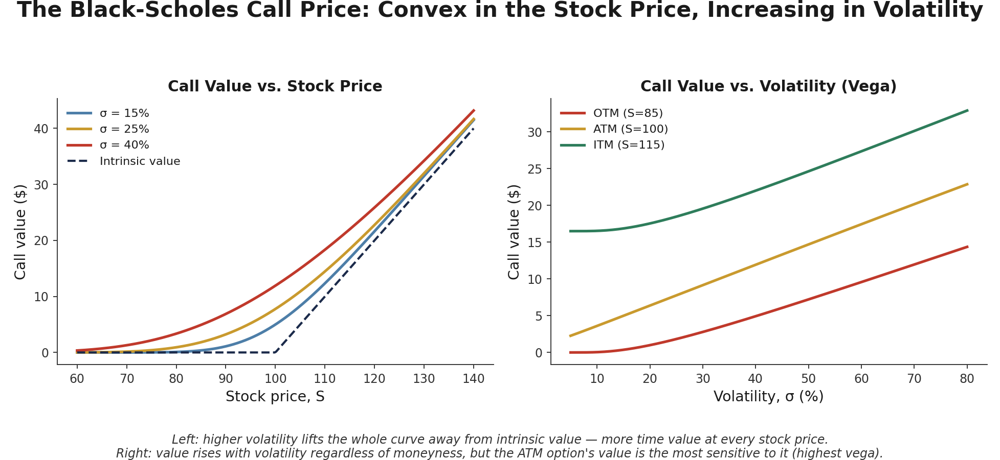
Figure 5.1 — Left: the Black-Scholes call price as a function of the stock price, for three different volatilities, always sitting above intrinsic value by the amount of time value. Right: the same call's price as a function of volatility alone, for three different moneyness levels — value rises monotonically with volatility in every case, the defining relationship behind vega (Section 7.2).
Tip — Black-Scholes prices are always strictly positive for any strictly positive volatility and any positive time to expiry, even for options far out of the money — there is always some, however small, probability of finishing in the money before expiry. A deep-OTM option quoted at exactly zero is a data or model artefact, not a genuine Black-Scholes output.

Part 6 — Implied Volatility
Every input to the Black-Scholes formula is directly observable — the stock price, the strike, the time to expiry, the risk-free rate — except volatility, which cannot be observed directly and must instead be estimated or inferred. Implied volatility flips the formula around: instead of an input, it treats volatility as the unknown to be solved for, given an observed market price.

6.1 Inverting Black-Scholes for Volatility
Given an option's observed market price, its implied volatility is the value of σ that makes the Black-Scholes formula reproduce that price exactly:
Find σ such that: BS_price(S, K, T, r, σ) = Market price
Black-Scholes has no closed-form inverse for σ, so implied volatility is found numerically — typically with a root-finding routine (Newton-Raphson or a bisection-style method such as Brent's) that repeatedly adjusts a trial σ until the model price matches the market price to within a tight tolerance.
from scipy.optimize import brentq

def implied_vol(market_price, S, K, T, r):
objective = lambda sigma: bs_call(S, K, T, r, sigma) - market_price
return brentq(objective, 1e-6, 5.0) # search between ~0% and 500% vol
Common mistake — Treating implied volatility as a prediction of future realised volatility rather than a market-implied price input. Implied volatility is, definitionally, just Black-Scholes' price restated in volatility units — it reflects the market's current supply and demand for that option (including any premium for uncertainty about future volatility itself), not a calibrated forecast. Comparing implied volatility to subsequently realised volatility is a legitimate and common research exercise (the volatility risk premium), but that is a separate empirical question from what implied volatility is by construction.

6.2 The Volatility Smile and Skew
If the Black-Scholes constant-volatility assumption held exactly, every option on the same underlying and expiry would imply the identical volatility, regardless of strike — a flat line. In practice, implied volatility varies systematically and persistently by strike, in patterns that differ by asset class:
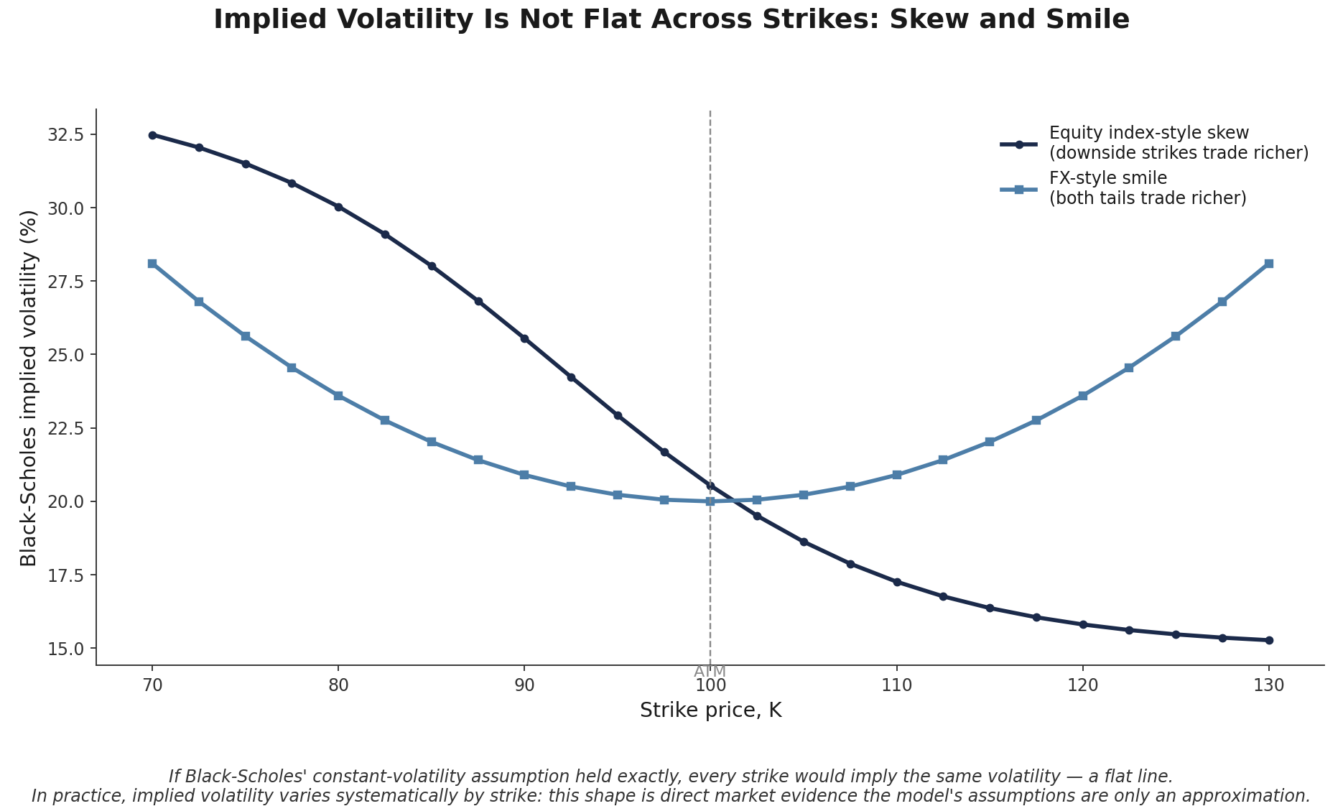
Figure 6.1 — Two common implied-volatility shapes. Equity index options typically show a downward skew: low (downside) strikes trade at persistently higher implied volatility than high strikes, largely reflecting demand for crash protection and the empirical tendency of equity volatility to rise when prices fall. FX options more often show a symmetric smile: both far-OTM strikes trade richer than at-the-money, reflecting fat tails in both directions.
This pattern is direct market evidence that the Black-Scholes assumptions are only an approximation — real asset returns are not exactly log-normal with constant volatility, and the market prices options accordingly. The smile and skew are the starting point for the more advanced volatility models (local volatility, stochastic volatility) surveyed in Advanced Extensions below.

Part 7 — The Greeks: Risk Sensitivities
The Greeks are the partial derivatives of an option's price with respect to each of its inputs — the standard vocabulary for describing exactly how, and how much, an option's value will change if the market moves. A trading desk holding an options book manages its exposure primarily by monitoring and hedging these quantities in real time, not by re-running the full pricing model after every tick.

7.1 Delta and Gamma
Delta measures the option's price sensitivity to the underlying:
Delta (call) = ∂C/∂S = N(d₁) ∈ (0, 1) Delta (put) = ∂P/∂S = N(d₁) − 1 ∈ (−1, 0)
Delta is also the number of shares of the underlying a trader must hold (with the opposite sign) to be instantaneously hedged against small moves in the stock — the basis of delta hedging. Gamma measures how quickly delta itself changes:
Γ = ∂Δ/∂S = ∂²C/∂S² = N′(d₁) / (Sσ√T)
Gamma is largest for at-the-money options close to expiry — exactly where delta is changing most rapidly as the underlying moves — and is the reason a delta hedge must be rebalanced periodically (dynamic hedging) rather than set once and left alone.

7.2 Vega, Theta, and Rho
Vega measures sensitivity to implied volatility, theta to the passage of time, and rho to the risk-free rate:
ν = ∂C/∂σ = S√T · N′(d₁) Θ = ∂C/∂t (usually negative for a long option) ρ = ∂C/∂r = KTe^(−rT)N(d₂)
Vega is largest for at-the-money options with more time to expiry — consistent with Figure 5.1's observation that time value (which vega measures the sensitivity of) is greatest there. Theta is usually negative for a long option position — value erodes as expiration approaches, all else equal — which is exactly the sagging-toward-intrinsic-value behaviour shown in Figure 2.2. Rho matters most for longer-dated, deep in-the-money options, where the discounting of the strike over a long horizon is more consequential.
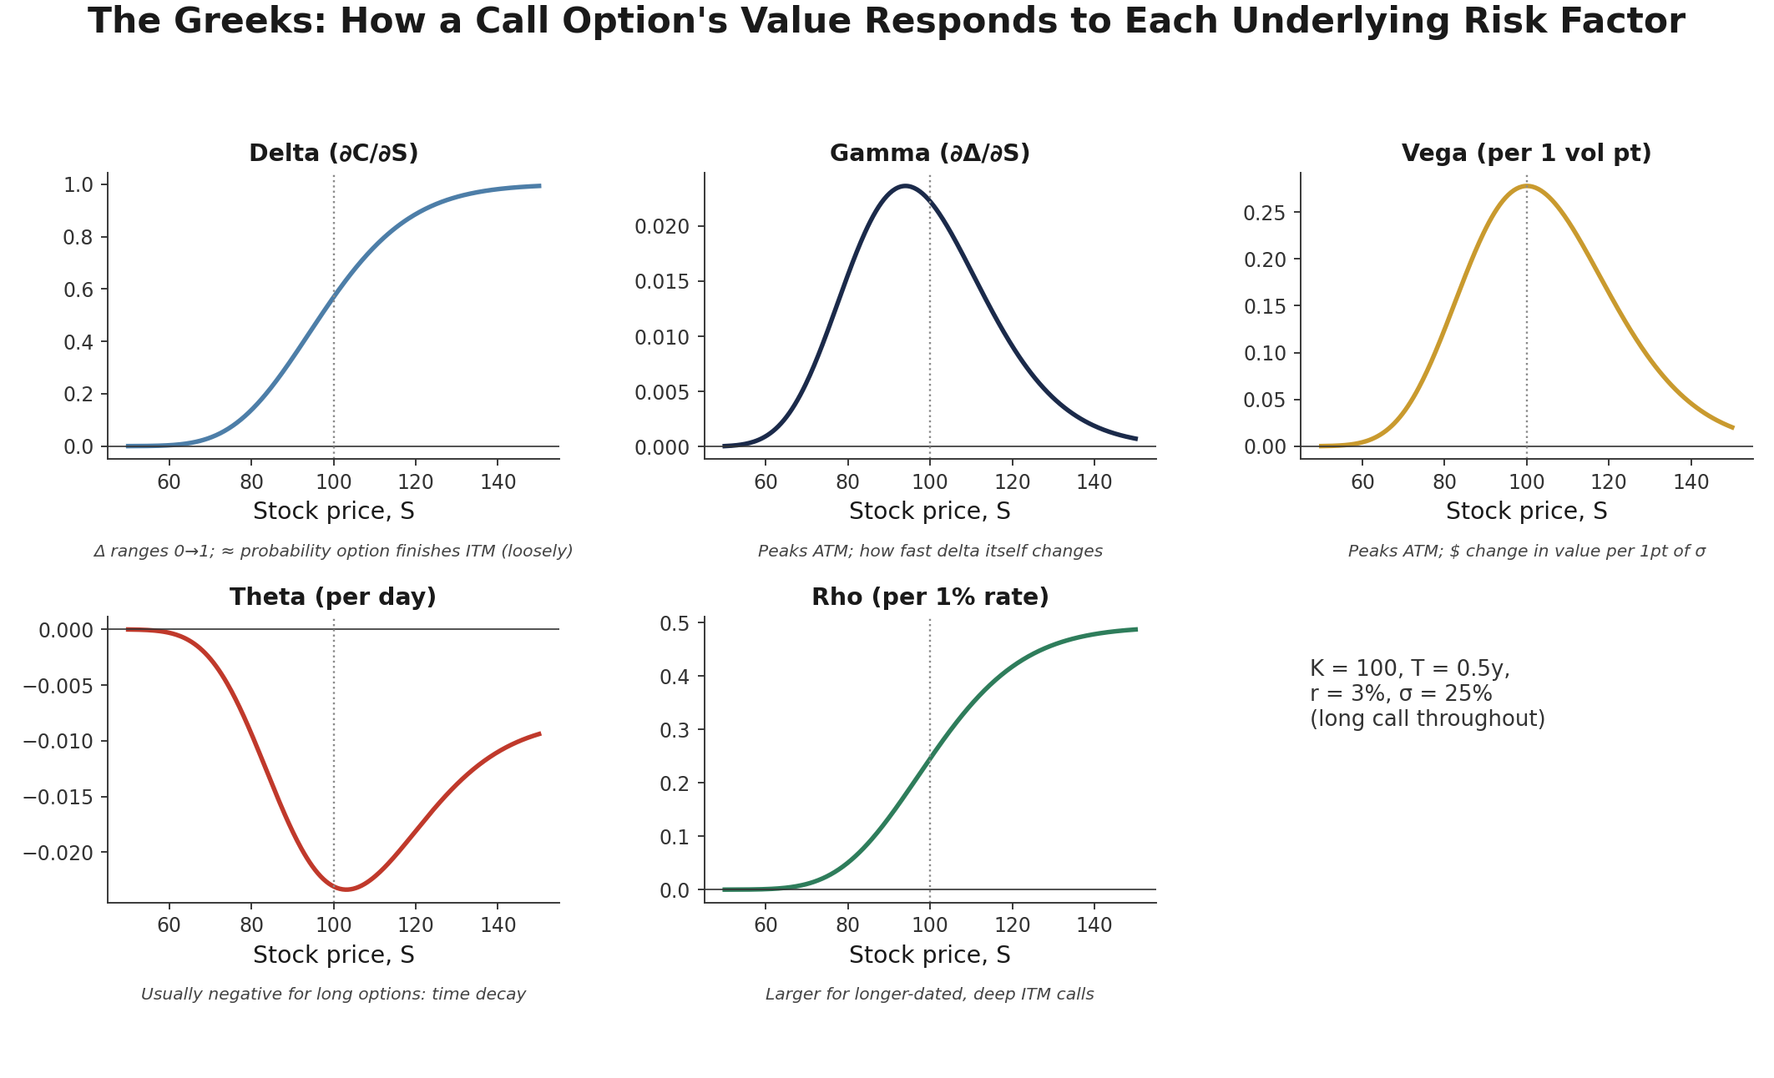
Figure 7.1 — All five Greeks for a call option (K=100, T=0.5y, r=3%, σ=25%) plotted against the underlying price. Delta rises monotonically from 0 to 1; gamma and vega both peak at the money; theta is most negative near the money (fastest decay where the most time value sits); rho rises with the underlying, largest for deep in-the-money calls.
Worked example — for the same 6-month, ATM call as Section 5.1 (S=100, K=100, r=3%, σ=22%): Δ ≈ 0.569, Γ ≈ 0.0253, vega ≈ 0.278 per volatility point, theta ≈ −0.021 per day, rho ≈ 0.250 per 1% move in rates.
delta = norm.cdf(d1)
gamma = norm.pdf(d1) / (S0 * sigma * np.sqrt(T))
vega = S0 * norm.pdf(d1) * np.sqrt(T) / 100 # per 1 vol point
theta = (-S0*norm.pdf(d1)*sigma/(2*np.sqrt(T)) - r*K*np.exp(-r*T)*norm.cdf(d2)) / 365
rho = K * T * np.exp(-r*T) * norm.cdf(d2) / 100 # per 1% rate move

7.3 Reading the Greeks Together as a Risk Dashboard
No single Greek describes an options position on its own — a book that is delta-neutral (hedged against small moves) can still carry substantial gamma risk (a large loss on a big move that overwhelms the small-move hedge), vega risk (a loss if implied volatility itself moves even with the stock unchanged), and theta that is either bleeding away value daily (long options) or accruing it (short options). Reading the Greeks together — rather than any one in isolation — is what turns them from a set of formulas into an actual risk-management dashboard.
Why this matters for trading — A position can be delta-hedged and still lose money: if the underlying gaps sharply (gamma exposure realised) or implied volatility itself repricess (vega exposure realised), a delta-neutral book is not remotely risk-neutral. Desks routinely monitor delta, gamma, and vega simultaneously — and set explicit limits on each — for exactly this reason.

Practical Exercise
Using the parameters S₀ = 100, K = 100, T = 0.5 years, r = 3%, σ = 22% (the same inputs as the worked examples in Part 5 and Section 7.2):
- Price the European call using the Black-Scholes formula (Section 5.1), and separately verify the price using a binomial tree with a large number of steps (Section 4.2) — confirm the two converge closely.
- Compute all five Greeks — delta, gamma, vega, theta, and rho (Part 7) — analytically using the closed-form formulas.
- Verify delta numerically: reprice the call at S₀+ε and S₀−ε for a small bump ε (e.g., $0.01) and compute the central finite-difference estimate [C(S+ε) − C(S−ε)] / (2ε); confirm it closely matches the analytical delta.
- Verify gamma numerically in the same way, using the second-difference formula [C(S+ε) − 2C(S) + C(S−ε)] / ε², and confirm it closely matches the analytical gamma.
- Repeat the price using put-call parity (Section 3.1) starting from the put price alone, and confirm it recovers the same call price computed directly.
eps = 0.01
delta_numeric = (bs_call(S0+eps, K, T, r, sigma) - bs_call(S0-eps, K, T, r, sigma)) / (2*eps)
gamma_numeric = (bs_call(S0+eps, K, T, r, sigma) - 2*bs_call(S0, K, T, r, sigma)
+ bs_call(S0-eps, K, T, r, sigma)) / (eps**2)

print(delta_numeric, delta) # should match to several decimal places
print(gamma_numeric, gamma) # should match to several decimal places

Common Beginner Mistakes
Common mistake — Treating implied volatility as a prediction of future realised volatility rather than a market-implied price input. As Section 6.1 covers, implied volatility is Black-Scholes' price restated in volatility units — a snapshot of current market pricing, not a calibrated forecast, however tempting it is to read a rising implied-volatility number as the market 'predicting' turbulence.

Common mistake — Using Black-Scholes assumptions (constant volatility, no jumps) uncritically for products where they clearly fail — for example, deep out-of-the-money options near an earnings announcement, where the actual distribution of outcomes is far from log-normal (a binary-like jump is genuinely likely) and implied volatility itself is elevated and rapidly time-varying precisely because the constant-volatility assumption is a poor description of what is about to happen.

Advanced Extensions
Volatility surfaces extend the single-strike smile of Section 6.2 into a full two-dimensional surface across both strike and expiry, giving a complete picture of how implied volatility varies across the entire set of traded options on an underlying at once. Local volatility and stochastic volatility models go a step further, replacing Black-Scholes' constant σ with volatility that varies with the underlying price and time (local volatility) or with its own separate random process (stochastic volatility, e.g., the Heston model) — both are attempts to build a single, internally consistent model that reproduces the smile rather than treating it as an anomaly to work around. Jump diffusion models add the possibility of sudden, discontinuous moves in the underlying (relevant precisely in the earnings-announcement scenario flagged in the mistakes above), and exotic options (barriers, Asians, look-backs) require pricing techniques — often Monte Carlo simulation or finite-difference PDE methods — beyond the closed-form and simple-tree approaches of this module. All of these are deferred to full treatment at Level 5 of the curriculum: the core pricing logic, no-arbitrage relationships, and Greeks covered here need to be second nature first, since every one of these extensions is a refinement of the same risk-neutral pricing framework, not a different framework altogether.

Professional Applications
- Hedging — corporations, asset managers, and trading desks use forwards, futures, and options to offset unwanted exposure to a price, rate, or currency, converting an otherwise open risk into a known, bounded one.
- Volatility trading — desks and funds take explicit positions on the future level of realised or implied volatility itself (rather than on the direction of the underlying), using the vega exposure of Section 7.2 as their primary risk and return driver.
- Structured product construction — many retail and institutional structured products (capital-protected notes, autocallables, and similar) are built by combining bonds with options in the payoff shapes covered in Part 2 and Part 3, priced using exactly the machinery in this module.

Where to Go Next
This module gives you the core pricing vocabulary — payoffs, moneyness, put-call parity, binomial trees, Black-Scholes, implied volatility, and the Greeks — that underpins essentially every more advanced derivatives topic in the curriculum. Nearly everything that follows involving options assumes these mechanics and this vocabulary are already second nature, rather than re-deriving them from scratch.

Suggested paths depending on your focus
- Heading into research: build a small implied-volatility surface from real listed-option data and examine how its skew shape varies across expiries, as groundwork for the volatility risk-premium research flagged in How This Connects to the Rest of the Curriculum.
- Heading into development: implement and unit-test a shared Black-Scholes and binomial-tree pricing library, including all five Greeks, with the finite-difference checks from the Practical Exercise built in as automated regression tests.
- Heading into trading: practise reading a simulated options book's aggregate delta, gamma, and vega together, and identify what a delta-neutral-but-gamma-heavy or delta-neutral-but-vega-heavy position actually exposes you to.

